

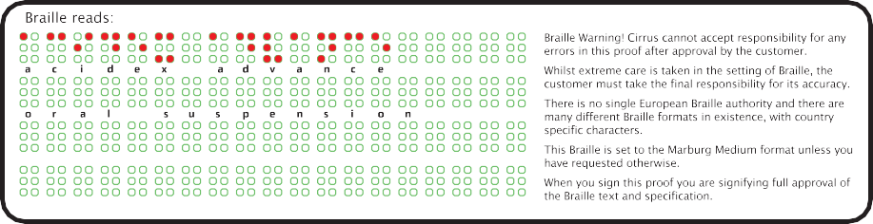
5 012727 913735

BN: EXP: |  |   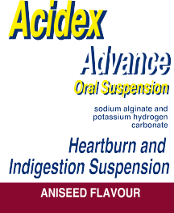      Each 10ml of the oral suspension contains 1000mg of sodium alginate and 200mg of potassium hydrogen carbonate. Also contains parahydroxybenzoates (Parabens, E214 and E216) which may cause allergic reactions (possibly delayed). This medicinal product contains about 5.1mmol of sodium and 2mmol of potassium per 10ml dose. To be taken into consideration by patients on a controlled sodium diet or when taking  drugs which can increase potassium levels. Care should also be taken if on calcium controlled diet. Read the attached leaflet carefully before use. To be taken by mouth after meals and at bedtime. Shake bottle well before use. Keep out of the sight and reach of children. Take special care if you are allergic to any of the ingredients of this medicine. Side effects are occasional. See leaflet for further information. Store below 25°C. Do not use after the expiry date shown on the label.  Do not refrigerate or freeze.  MA Holder: Wockhardt UK Ltd, Ash Road North, P  Wrexham, LL13 9UF, UK. UK Only  PL 29831/0697 23LL05953PW 108171/5 250ml |  | 

 | PACKAGE LEAFLET: INFORMATION FOR THE USER  Acidex Advance Oral Suspension  sodium alginate 1000mg/10ml, potassium hydrogen carbonate 200mg/10ml  Read all of this leaflet carefully before you start taking this medicine.  This medicine is available without prescription. However, you still need to use the product carefully to get the best results from it. You must contact a doctor if your symptoms worsen or do not improve after seven days.  - Keep this leaflet. You may need to read it again.  - If you have any further questions, ask your doctor or pharmacist.  - If any of the side effects gets serious, or if you notice any side effects not listed in this leaflet, please tell your doctor or pharmacist.  In this leaflet:  - What Acidex Advance is and what it is used for  - Before you take Acidex Advance  - How to take Acidex Advance  - Possible side effects  - How to store Acidex Advance  - Further information  - WHAT ACIDEX ADVANCE IS AND WHAT IT IS USED FOR  Acidex Advance Oral Suspension (referred to as ‘Acidex Advance’ throughout this leaflet) belongs to a group of medicines called “reflux suppressants”. Reflux is when the acid stomach contents flow back up the gullet (oesophagus) and this can cause pain and discomfort known as heartburn or acid indigestion. This medicine contains the active ingredients sodium alginate and potassium hydrogen  carbonate which together form a protective layer at the top of your stomach to stop reflux from |  |  | happening by keeping the stomach contents away from the lining of the food pipe to relieve the symptoms of heartburn and acid indigestion. It can therefore be taken to prevent and relieve the symptoms of acid reflux, including during pregnancy and relieve the symptoms of conditions such as hiatus hernia (protrusion of muscle through a muscle wall), reflux oesophagitis (inflamed foodpipe) and symptoms of hoarseness and other voice disorders, sore throat and cough associated with reflux. It can also be taken to control heartburn symptoms which may occur when taking, or following withdrawal of medication to reduce stomach acid such as Proton Pump Inhibitors (PPIs) or H2 Antagonists.  - BEFORE YOU TAKE ACIDEX ADVANCE  Do not take Acidex Advance if you:  - are allergic (hypersensitive) to any of the ingredients in this medicine, including the esters of hydroxybenzoates (parabens) (see Section 6 and end of Section 2)  Warnings and precautions:  This medicine contains sodium (5.1mmol per 10ml), potassium (2.0mmol per 10ml) and calcium.  - If you have been advised to follow a diet restricted in any of these please consult you doctor before taking this product.  - The maximum recommended daily dose of this medicinal product contains 424mg sodium (found in table salt). This is equivalent to 21% of the adult recommended maximum daily intake for sodium.  - Please also talk to your doctor or pharmacist if you need this product on a daily basis for a prolonged period, especially if you have been advised to follow a low salt (sodium) diet or if you suffer or have suffered from significant kidney or heart disease, as certain salts could interfere with these diseases.  Taking other medicines  Please tell your doctor or pharmacist if you are taking or have recently taken any other medicines, |  |  | including medicines obtained without prescription. Wait at least 2 hours between taking this medicine and other medicines such as tetracyclines, fluoroquinolones (types of antibiotics), iron salts, thyroid hormones, chloroquine (a medication used to prevent malaria), bisphosphonates (a medication used to treat osteoporosis) and estramustine (a medication to treat prostate cancer).  Pregnancy and breast-feeding  This medicine can be used during pregnancy and breast-feeding, however it is recommended to limit the treatment duration as much as possible.  Driving and using machines  There are no known effects of this medicine on ability to drive or operate machinery.  Important information about some of the ingredients of Acidex Advance  This medicine also contains:  - Parahydroxybenzoates: may cause allergic reactions, possibly delayed  - Sodium: Each 10ml dose of this medicine contains about 5.1mmol of sodium and therefore care should be exercised in patients on a sodium restricted diet.  - Potassium: Each 10ml dose of this medicine contains about 2mmol of potassium and therefore care should be taken when taking drugs which can increase potassium levels.  3. HOW TO TAKE ACIDEX ADVANCE  To be taken by mouth, after meals and at bedtime. Shake bottle well before use. If you are unsure how  to use this medicine, check with your doctor or pharmacist.
 |  |  |  |  |  |  |  | Adults including the elderly and  children 12 years and over: | 5 – 10ml (one to two 5ml spoonfuls) after meals  and at bedtime.
 |  |  |  |  |  |  |  | Children under 12 years: | Should only be taken on medical advice.


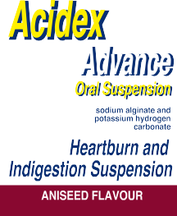


Each 10ml of the oral suspension contains 1000mg of sodium alginate and 200mg of potassium hydrogen carbonate. Also contains parahydroxybenzoates (Parabens, E214 and E216) which may cause allergic reactions (possibly delayed). This medicinal product contains about 5.1mmol of sodium and 2mmol of potassium per 10ml dose. To be taken into consideration by patients on a controlled sodium diet or when taking
drugs which can increase potassium levels. Care should also be taken if on calcium controlled diet. Read the attached leaflet carefully before use. To be taken by mouth after meals and at bedtime. Shake bottle well before use. Keep out of the sight and reach of children. Take special care if you are allergic to any of the ingredients of this medicine. Side effects are occasional. See leaflet for further information. Store below 25°C. Do not use after the expiry date shown on the label.
Do not refrigerate or freeze.
MA Holder: Wockhardt UK Ltd, Ash Road North, P
Wrexham, LL13 9UF, UK. UK Only
PL 29831/0697 23LL05953PW 108171/5 250ml
 |  | WARNING: DO NOT EXCEED THE STATED DOSE |  |  |  | which is stated on the pack. The expiry date refers to the last day of that month.  Use within 3 months of opening. Medicines should not be disposed of via wastewater or household waste. Ask your pharmacist how to dispose of medicines no longer required. These measures will help to protect the environment.  - FURTHER INFORMATION  What Acidex Advance contains:  - The active ingredients are: Sodium alginate 1000mg/10ml, Potassium hydrogen carbonate 200mg/10ml  - The other ingredients are: Calcium Carbonate, Carbomer, Sodium Hydroxide, Saccharin Sodium, Ethyl Parahydroxybenzoate (E214), Propyl Parahydroxybenzoate (E216), Butyl Parahydroxybenzoate, Isopropyl Alcohol, Star Anise Oil and Purified Water (see end of Section 2 for further information)  What Acidex Advance looks like and contents of the pack  This medicine is an aniseed flavoured white or cream coloured suspension.  It comes in amber glass bottles of 150ml, 200ml, 250ml, 300ml and 500ml with white polypropylene caps. Not all pack sizes may be marketed.  Marketing Authorisation Holder  Wockhardt UK Ltd, Ash Road North, Wrexham, LL13 9UF, UK.  Manufacturer  Pinewood Laboratories Limited, Ballymacarbry, Clonmel, Co. Tipperary, Ireland.  PL 29831/0697  This leaflet was last updated in 10/2022.
If you take more of this medicine than you should
If you take too much of this product you may feel bloated and experience some abdominal discomfort. It is unlikely to cause you any harm, but please consult your doctor or pharmcist if this doesn’t go away. If symptoms persist after 7 days consult your doctor.
If you forget to take this medicine
If you forget to take your medicine, take it as soon as you remember, Do not take a double dose to make up for the forgotten dose.
- POSSIBLE SIDE EFFECTS
Like all medicines, this product can cause side effects, although not everybody gets them.
Very rarely (less than 1 in 10,000 patients) there is a chance of an allergic reaction to the ingredients. Symptoms of this may include difficulty breathing, hives and swelling of the face. Uncommonly reported side-effects are diarrhoea, nausea and vomiting. If you experience these or any other side effects stop taking the product and consult your doctor immediately.
Reporting of side effects:
If you get any side effects, talk to your doctor, pharmacist or nurse. This includes any possible side effects not listed in this leaflet. You can also report side effects directly via the Yellow Card Scheme at www.mhra.gov.uk/yellowcard or search for MHRA Yellow Card in the Google Play or Apple App Store. By reporting side effects you can help provide more information on the safety of this medicine
- HOW TO STORE ACIDEX ADVANCE
Keep out of the sight and reach of children.
Do not store above 25°C. Do not refrigerate or freeze. Do not use this product after the expiry date

